University of Debrecen
Faculty of Informatics

THESIS

Pet Tracker Application
A Raspberry Pi sensor node and an Android client for monitoring a household pet

Supervisor:  Dr. Gergely Kocsis  Associate Professor | Candidate:  Tareq Al-Medanat  Computer Science Engineering BSc
Debrecen
2027

Acknowledgements
I would like to thank my supervisor, Dr. Gergely Kocsis, for his guidance throughout this project, for steering it toward something that could actually be built and measured, and for his patience while the hardware fought back. I would also like to thank my family for their support during my studies, and for tolerating a hallway full of wires, sensors and a paddle-wheel feeder for an entire summer.

Table of contents

1. Introduction

1.1. Project motivation
The enduring bond between humans and their pet animals, where they are considered part of the family and live in the same household, creates the need for a means to monitor these animals. Nowadays owners seek reliable and advanced methods to keep an eye on them at all times, to ensure their well-being and security. The rise of smart technologies and mobile computing presents a significant opportunity to address the challenges associated with household pet management, particularly concerning feeding, daily routines, and knowing where in the house the animal has been while nobody was home.
This thesis presents the development of a Pet Tracker Application designed to link the main aspects of pet management into a single mobile application, backed by real hardware in the home. The system has two parts. A Raspberry Pi is wired to three motion sensors, a load cell under the food bowl, a servo-driven food dispenser, a GPS receiver and two cameras, and runs a Python service that records what the sensors observed into a local database and serves those observations over HTTP on the home network. An Android application polls the Pi, stores the readings locally, and presents them to the owner: food eaten today, rooms visited, a live camera view with on-device animal detection, and a button that runs the feeder. In one sentence, the project is an end-to-end pet monitoring system in which a Raspberry Pi sensor node buffers observations locally and an Android client reconciles them idempotently, with each screen constrained to state only what a sensor actually measured.
The primary motivation for this choice of project stems from the need for an easy to use, centralized solution to problems that are usually handled in fragmented or reactive ways: owners overlooking changes in their pet's eating, not knowing what the animal does while they are away, and relying on guesswork instead of information. Commercial pet cameras and feeders exist, but they are cloud-bound appliances: the data leaves the house, the device stops working when the vendor's service does, and the owner cannot inspect or extend any part of the chain. Building the system myself keeps every reading on hardware I own, and it exposes every design decision to examination, from the electrical level (why the feeder's servo must not draw its current through the Pi) to the user-interface level (why an empty reading must never be rendered as a zero). This application seeks to provide a proactive solution that offers peace of mind to pet owners by keeping them informed and connected to their animals, without ever telling them more than the sensors actually know.

1.2. The central design question
The central technical question the whole design answers is a consequence of one simple fact: the phone is not always on the home network. Readings therefore cannot be delivered as they happen and forgotten; a meal eaten at noon must still be reportable when the owner opens the application at six in the evening. The Pi consequently buffers every observation in an append-only local database, and the application collects whatever it missed each time it is opened. Everything else in the architecture follows from taking that fact seriously rather than wishing it away: the cursor-based event feed, the idempotent synchronisation, and the decision not to poll in the background.
A second principle runs through the project and is defended at length in the discussion chapter: every screen states only what a sensor actually measured, and “no data” is never rendered as zero. A monitoring system earns trust by refusing to invent. A dashboard that shows “0 g eaten” when no scale is connected is lying twice, once about the number and once about knowing it. This principle shaped the data model, the wording of the user interface, and even the naming of database columns, and it is the reason several superficially attractive features were rejected.

1.3. Objectives
At the outset I set the following targets for the project:
- Build a sensor node on a Raspberry Pi that reads motion, weight, position and camera data from real hardware, survives reboots and power loss, and needs no attention once installed.
- Define a small, stable HTTP contract between the node and the phone, so that either side can be developed, tested and replaced without the other.
- Build an Android application that reconciles buffered readings correctly even after connection loss, cursor resets or repeated delivery, and presents them without overstating what is known.
- Verify the whole chain, from sensor to screen, on real hardware, with automated tests covering everything that can be tested without hardware and bring-up tooling for everything that cannot.
The targets deliberately exclude several things a commercial product would include: cloud synchronisation, multi-user access, secured transport, and tracking the animal outside the home. Chapter 10 states these limitations honestly and explains which are design decisions and which are simply unfinished.

1.4. Method and structure of the thesis
The method was incremental. Each hardware component was first tested individually with dedicated diagnostic tooling before being integrated into the complete system; this allowed testing whether each part works properly on its own, and made debugging easier, because with one component under test there are only a limited number of variables. Each software layer was written against a simulated version of the layer below it, and the complete system was verified on a real rig, a Raspberry Pi in the hallway of a real home together with a physical Android phone, on 30 August 2026. The project comprises roughly 4,700 lines of Python on the Pi and 6,500 lines of Java in the application, developed over four months and guarded by 376 automated tests. Where this thesis states a number, that number was measured on the real system; where something was not measured, the text says so.
The thesis is organised as follows. Chapter 2 describes the hardware and the electrical decisions behind it. Chapter 3 presents the system architecture: the two halves, the HTTP contract that joins them, and the data model on each side. Chapters 4 and 5 describe the two software halves in detail, the Python sensor node and the Android application. Chapter 6 covers testing and verification, and Chapter 7 recounts six real engineering incidents encountered during the bring-up, each with the diagnosis and the general lesson it taught. Chapter 8 collects the measured results, Chapter 9 discusses the design principle and the alternatives that were rejected, Chapter 10 states the limitations and future work, and Chapter 11 concludes.

2. Hardware
To implement the proposed Pet Tracker Application, it was important to select hardware components that support high-level programming, provide sufficient computational performance, and offer flexibility for integrating multiple peripherals and interfaces. The project involves real-time image capture, several types of sensor monitoring, and communication between the mobile application and the main controller, so the platform needed to be capable of data acquisition, processing, and serving the results back, all at the same time. Initially a simpler microcontroller-based central processor was considered due to ease of use and setup, but it was deemed too weak in terms of the computational power required for continuous camera operation and an HTTP server, and its networking capabilities are limited without additional modules. Given all these conditions a more powerful system was necessary, and the Raspberry Pi 4 was selected as the central processing unit and “brain” of the system. Figure 1 shows how all the components fit together, and Table 1 lists the full inventory; every entry in it was verified working on the assembled rig.
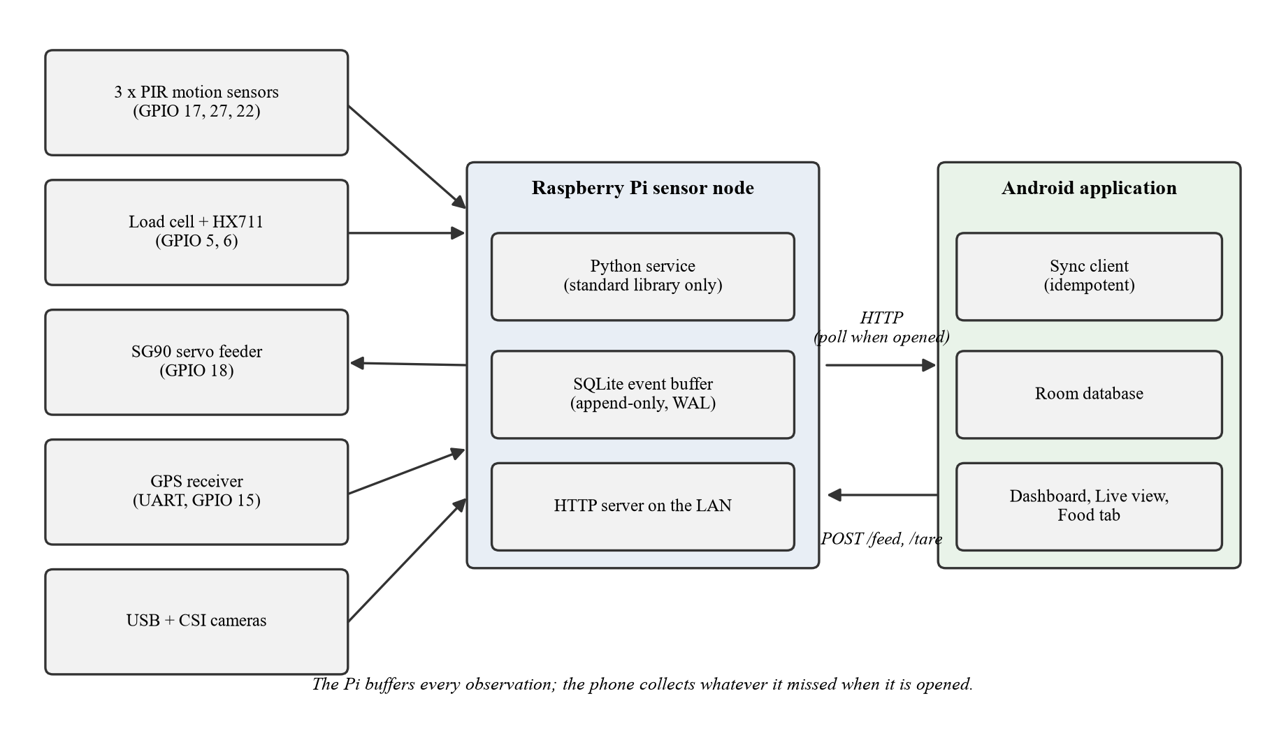
Figure 1: Overview of the system. The Pi buffers what the sensors saw; the application collects it over HTTP.
Component | Part | Connection | Verified by
Motion | 3 × PIR (HC-SR501) | GPIO 17, 27, 22 | 3 sensors firing, named per room
Load cell | 5 kg bar + HX711 amplifier | DT = GPIO 5, SCK = GPIO 6, VCC 3.3 V | Calibrated, 385.66 counts/g
Feeder | SG90 servo, paddle wheel | GPIO 18 signal; LM2596 buck at 5.0 V | Dispenses from the app
GPS | u-blox NEO-M8N receiver | module TX → GPIO 15 (RXD), 3.3 V | Fix from 12 satellites
Camera A | USB webcam | USB | Streams, snapshots
Camera B | CSI ribbon camera | CSI connector | 20/20 frames, 18.4 fps
Host | Raspberry Pi, Wi-Fi | (central unit) | systemd service, starts at boot
Table 1: Hardware inventory. Every component was verified on the assembled rig.

2.1. Raspberry Pi 4
The central and most important hardware component of the system is the Raspberry Pi 4 (Figure 2), which serves as the main processing unit, the brain of the system. This device has a good balance of computational performance and flexibility, with ease of integration and use, and it easily manages the number of peripherals required for the many features of the project. Unlike microcontroller-based platforms, the Raspberry Pi operates as a full single-board computer running a Linux-based operating system, Raspberry Pi OS, which unlocks high-level languages, mainly Python, with its libraries for image capture, networking and hardware control, as well as POSIX process management and systemd as a supervisor that starts the service at boot and restarts it on failure [10].
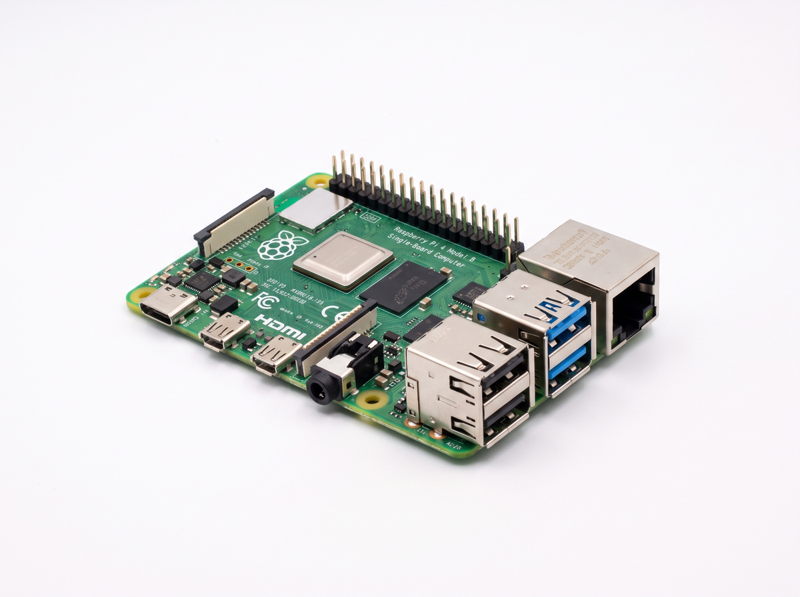
Figure 2: The Raspberry Pi 4 single-board computer (illustrative image).
The Raspberry Pi 4 is equipped with a multi-core processor and enough memory to handle multiple concurrent tasks. Its responsibility is to manage camera input, process sensor data, and handle communication with the mobile application. The forty-pin GPIO (general purpose input/output) header carries every sensor connection in Table 1, allowing direct interfacing with external components, including sensors and actuators, and the built-in Wi-Fi is the only network link the system needs, since the application talks to the Pi exclusively over the home LAN.
One property of the Pi shaped the software more than any specification on its datasheet: it has no real-time clock. Between power-on and the first NTP synchronisation the Pi genuinely believes the current year is 1970, and its clock then jumps forward by decades in an instant. Chapter 3 shows how this single fact dictated the design of the event feed's cursor, and Chapter 4 shows how it dictated the handling of timestamps.

2.2. Motion sensors – HC-SR501
For motion detection, three HC-SR501 passive infrared (PIR) sensors were incorporated into the system, one per monitored room, wired to GPIO pins 17, 27 and 22. This sensor (Figure 3) detects movement by measuring changes in the infrared radiation emitted by objects within its field of view. A digital output signal is obtained from the HC-SR501: the signal becomes high when motion is detected, and this signal is read by the Raspberry Pi through a GPIO pin. It was chosen for its low power consumption and its simple GPIO-based interface [9].
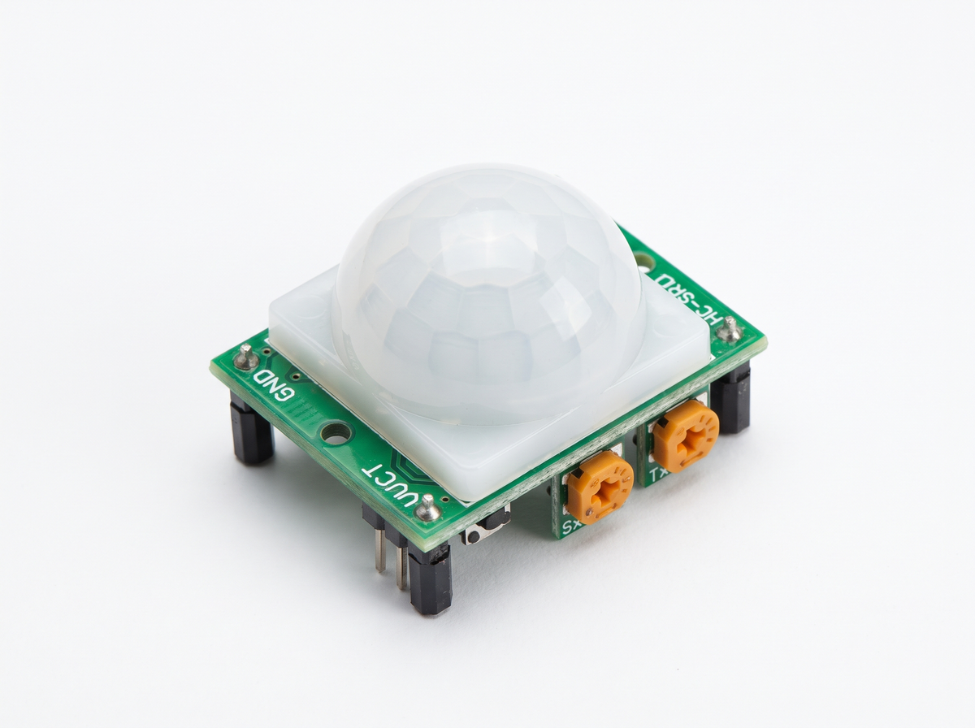
Figure 3: The HC-SR501 PIR motion sensor with its dome Fresnel lens (illustrative image).
The essential thing to understand about a PIR, and the thing the software must never forget, is that it reports movement, not presence. It fires while the cat crosses the kitchen and says nothing while the cat sleeps in it. It also cannot say what moved: a person and an animal produce the same pulse. Both facts are handled in software (Section 4.4) rather than papered over in the user interface, and both are stated as limitations in Chapter 10. A hardware detail matters here too: an HC-SR501 fires more or less constantly for about a minute after power-up while its pyroelectric element settles, so the service discards the first sixty seconds of output rather than recording the warm-up as a burst of motion.

2.3. The load cell and the HX711
Food consumption is measured by a 5 kg bar-type load cell under the food bowl, read through an HX711, a 24-bit analogue-to-digital converter purpose-built for weigh scales (Figure 4) [8]. The HX711 connects to the Pi with two lines, data on GPIO 5 and clock on GPIO 6, and speaks a bit-banged serial protocol described in Section 4.2.
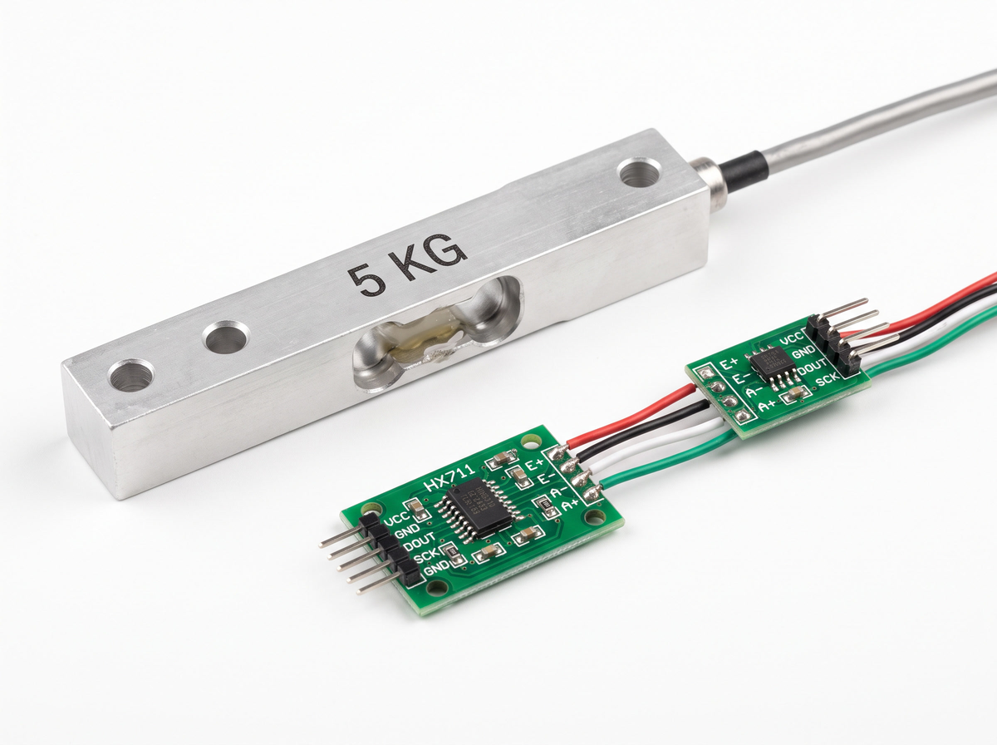
Figure 4: The 5 kg bar-type load cell with the HX711 amplifier board (illustrative image).
The HX711 board is powered from 3.3 V rather than 5 V, deliberately. At 5 V the board drives 5 V logic levels on its data line into a GPIO input that is only rated for 3.3 V, which is out of specification and risks damaging the Pi. The resolution lost by the lower excitation voltage is irrelevant at this application's scale factor: a full 5 kg span maps to about 1.9 million counts against the converter's ±8.4 million range, so nothing approaches saturation. One more electrical lesson about this board was learned the hard way and is written up as an incident in Chapter 7: it has no reverse-polarity protection, and reversing VCC and GND kills it silently. The module looks fine, the load cell is unharmed, and the data line simply never drives again.

2.4. The feeder and the power topology
The system includes an automated feeding mechanism, intended to provide remotely controlled feeding for the monitored pet at the user's request from the mobile application. Food is dispensed by a paddle wheel turned by an SG90 hobby servo (Figure 5) on GPIO 18. The wheel has pockets; one pocket-turn drops one portion into the bowl below. The mechanically interesting part of the design is not the wheel but the power supply, and it is worth describing because it is the kind of decision that never appears in software but decides whether the system survives.
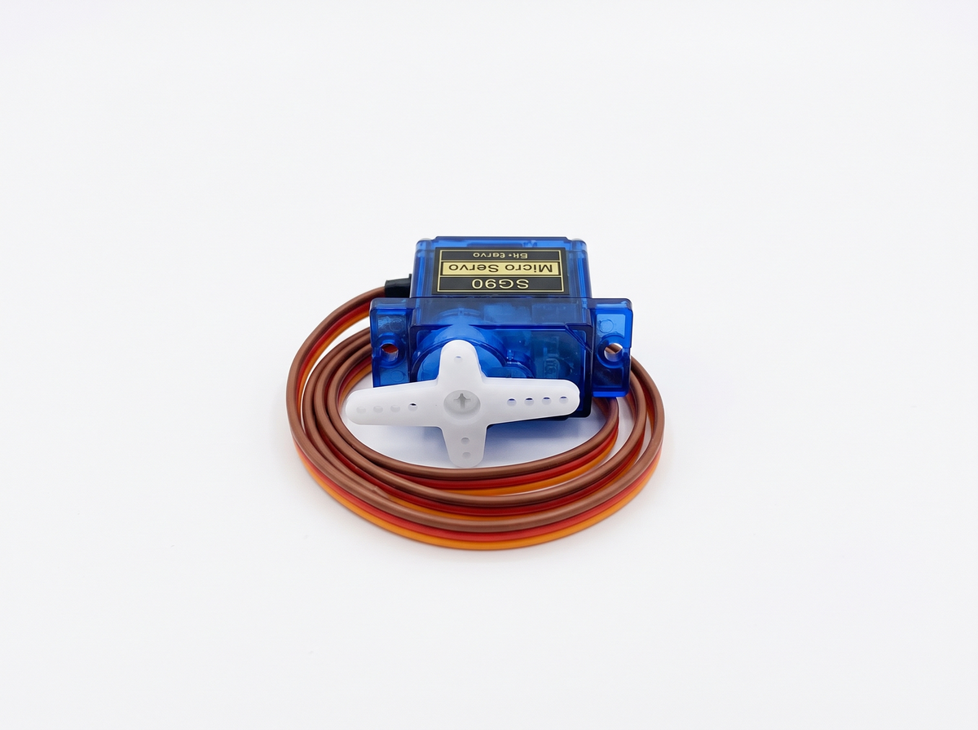
Figure 5: The SG90 micro servo that turns the feeder's paddle wheel (illustrative image).
The servo is not powered from the Pi. It is fed from a separate 12 V power supply, stepped down to 5.0 V by an LM2596 buck converter, and only the ground is shared with the Pi, so the servo's current never passes through the Pi while the control pulse on GPIO 18 still has a common reference (Figure 6). The reasoning: an SG90 stalled against jammed kibble draws close to an ampere, far beyond what the Pi's 5 V rail can supply without sagging, and a brown-out during an SD-card write is precisely how a Raspberry Pi corrupts its filesystem. A feeder that could destroy the database recording its own meals would be a poor design.
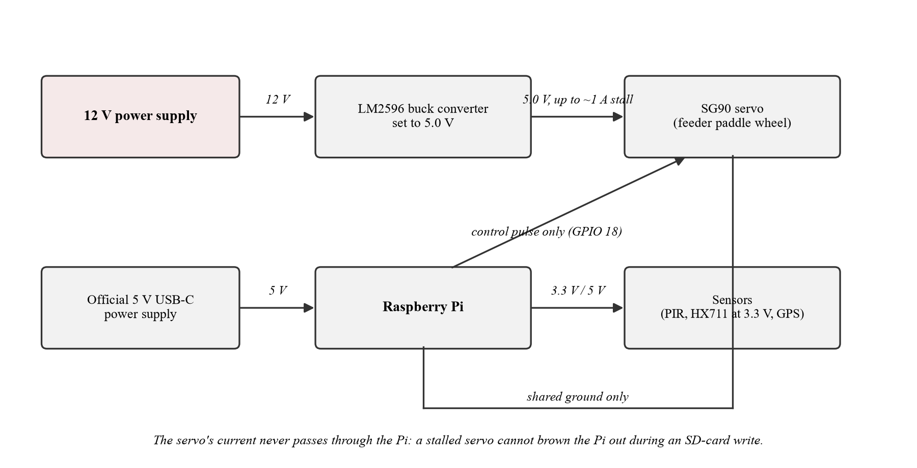
Figure 6: The power topology. The 12 V supply and the LM2596 buck converter feed the servo; only the ground is shared with the Pi.
A hobby servo has no position sensor, and this shapes the data model: neither the Pi nor the application ever knows whether the wheel actually turned or how much food actually fell. The load cell under the bowl is the only ground truth for what was dispensed, and Chapter 5 shows how the user interface is built around that fact. A dispense request records nothing; the meal arrives later, weighed.

2.5. GPS module – u-blox NEO-M8N
To track location, a u-blox NEO-M8N Global Navigation Satellite System (GNSS) module was integrated into the system (Figure 7). This module was selected for its positioning accuracy, fast signal acquisition, compatibility with multiple satellite systems, and its low cost relative to its accuracy compared to other available options. The module communicates with the Raspberry Pi through a Universal Asynchronous Receiver-Transmitter (UART) interface and outputs standard NMEA sentences, which contain information such as latitude, longitude, altitude and time [7].
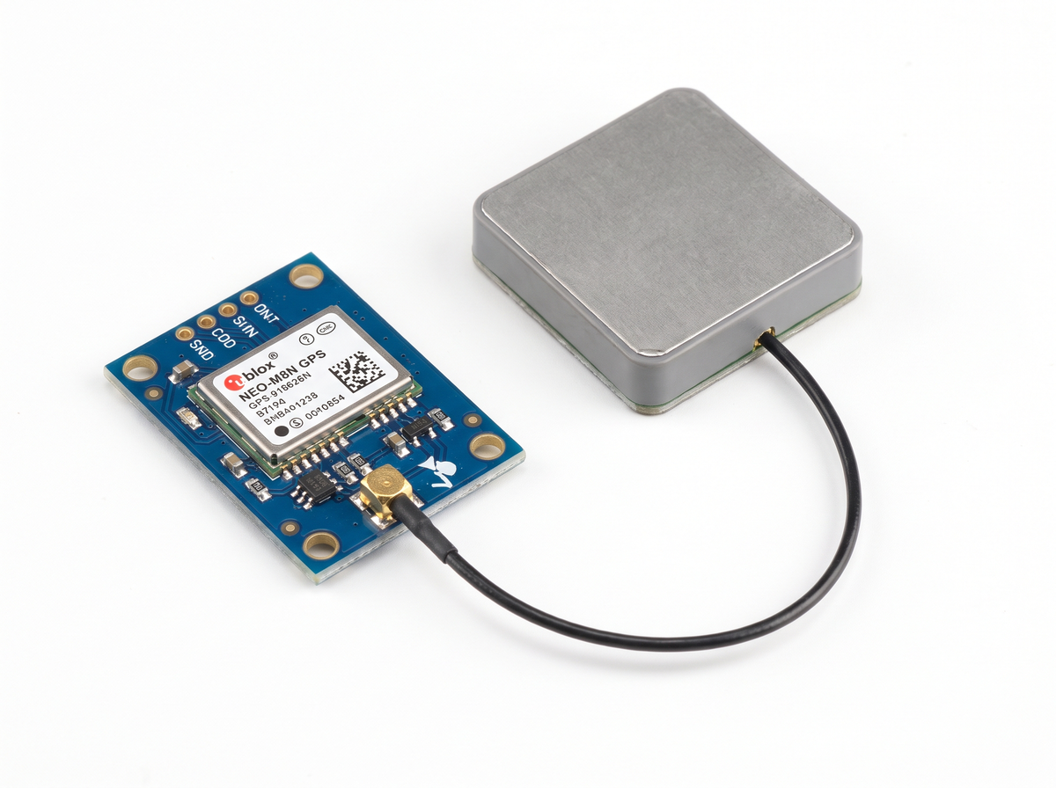
Figure 7: The u-blox NEO-M8N GPS module with its active patch antenna (illustrative image).
The wiring is three wires only: 3.3 V, ground, and the module's transmit pin into the Pi's receive pin (GPIO 15). The Pi's transmit pin is deliberately left disconnected: the service opens the serial port read-only and never writes, and connecting the unused line in an early session produced framing errors. The receiver needs an antenna tuned to the GPS L1 band at 1575.42 MHz; with a correct active antenna the module achieved a fix from twelve satellites at the rig's location. What those coordinates mean, and pointedly do not mean, is a recurring theme of this thesis: the GPS locates the tracker, the box in the hallway, not the pet. The system labels the reading accordingly at every level, from the database schema to the dashboard, and the wrong-antenna failure that preceded the fix is written up as an incident in Chapter 7.

2.6. Camera modules
There are two camera modules in the system, a native Pi camera and a USB camera, to ensure versatility in the type of video the application can provide. The Pi camera module connects through the CSI interface directly on the Pi and offers efficient performance with low latency; the USB camera provides flexibility in placement and compatibility with standard video interfaces. Using the two different buses is deliberate: a USB camera and a CSI camera cost nothing in shared bandwidth, whereas two USB webcams compete for the same bus. The CSI camera was verified at 20 out of 20 frames captured at 18.4 frames per second. A Raspberry Pi 4 has exactly one CSI connector, so “a camera in every room” is not possible on one host; Section 9.2 records that as a deferred design, not an abandoned one.
The cameras serve three purposes: a live MJPEG stream the application can watch, a JPEG snapshot saved on each motion event so the room chart can show what the camera saw, and a liveness signal (“camera live”) reported through the node's health endpoint. Only one process may hold a CSI camera at a time, which produces a distinctive failure mode when a second copy of the service is started by hand next to the supervised one; Chapter 7 describes it, and the wrapper class built to survive it.

3. System architecture
The system is two programs joined by one HTTP contract. Neither half knows anything about the other beyond that contract: the Pi service has no idea an Android application exists, and the application would work unchanged against any server honouring the same six endpoints. This chapter describes the shape of each half, the contract between them, and the data model that makes their reconciliation safe.

3.1. Two halves, one contract
The sensor node is a Python service of roughly 4,700 lines running on the Raspberry Pi. It polls the sensors, interprets their raw output into events, appends those events to a local SQLite database, and serves them over HTTP on the LAN. It is written against the Python standard library only, with no third-party dependencies at all. That is a deliberate constraint, not an accident of scope: a sensor node that must survive an operating-system reinstall and then run unattended for months is worth more when it cannot break through a dependency it did not choose to upgrade. Everything the service needs (an HTTP server, SQLite, threading, serial port access) ships with Python itself.
The mobile client is a Java Android application of roughly 6,500 lines across 45 classes and 13 layouts. It uses Room over SQLite for local storage, Firebase Authentication for user accounts, Glide for image loading, and CameraX with TensorFlow Lite for on-device object detection. When opened, it polls the Pi for whatever events it has missed, stores them locally, and renders them; it also shows the live stream, displays motion snapshots, and can command a feed.
The design pays for this separation in one place and profits from it everywhere else. The cost is that readings arrive with a delay of one poll. The profit is that each half can be developed, tested and verified alone: the Pi service runs on a laptop with simulated sensors, the application runs against that simulation, and 277 of the project's 376 automated tests run with no hardware and no network at all.

3.2. The HTTP contract
The contract consists of six endpoints, summarised in Table 2, shown in context in Figure 8, and specified in full in Appendix A.
Method | Path | Purpose
GET | /health | Per-sensor availability, uptime, latest cursor, latest weight
GET | /events?since=<id> | A page of buffered readings after a cursor
GET | /snapshot?name=<file> | One saved camera frame
GET | /stream | MJPEG live video
POST | /feed | {"grams": n}: run the feeder
POST | /tare | Zero the scale
Table 2: The HTTP contract between the sensor node and the application.
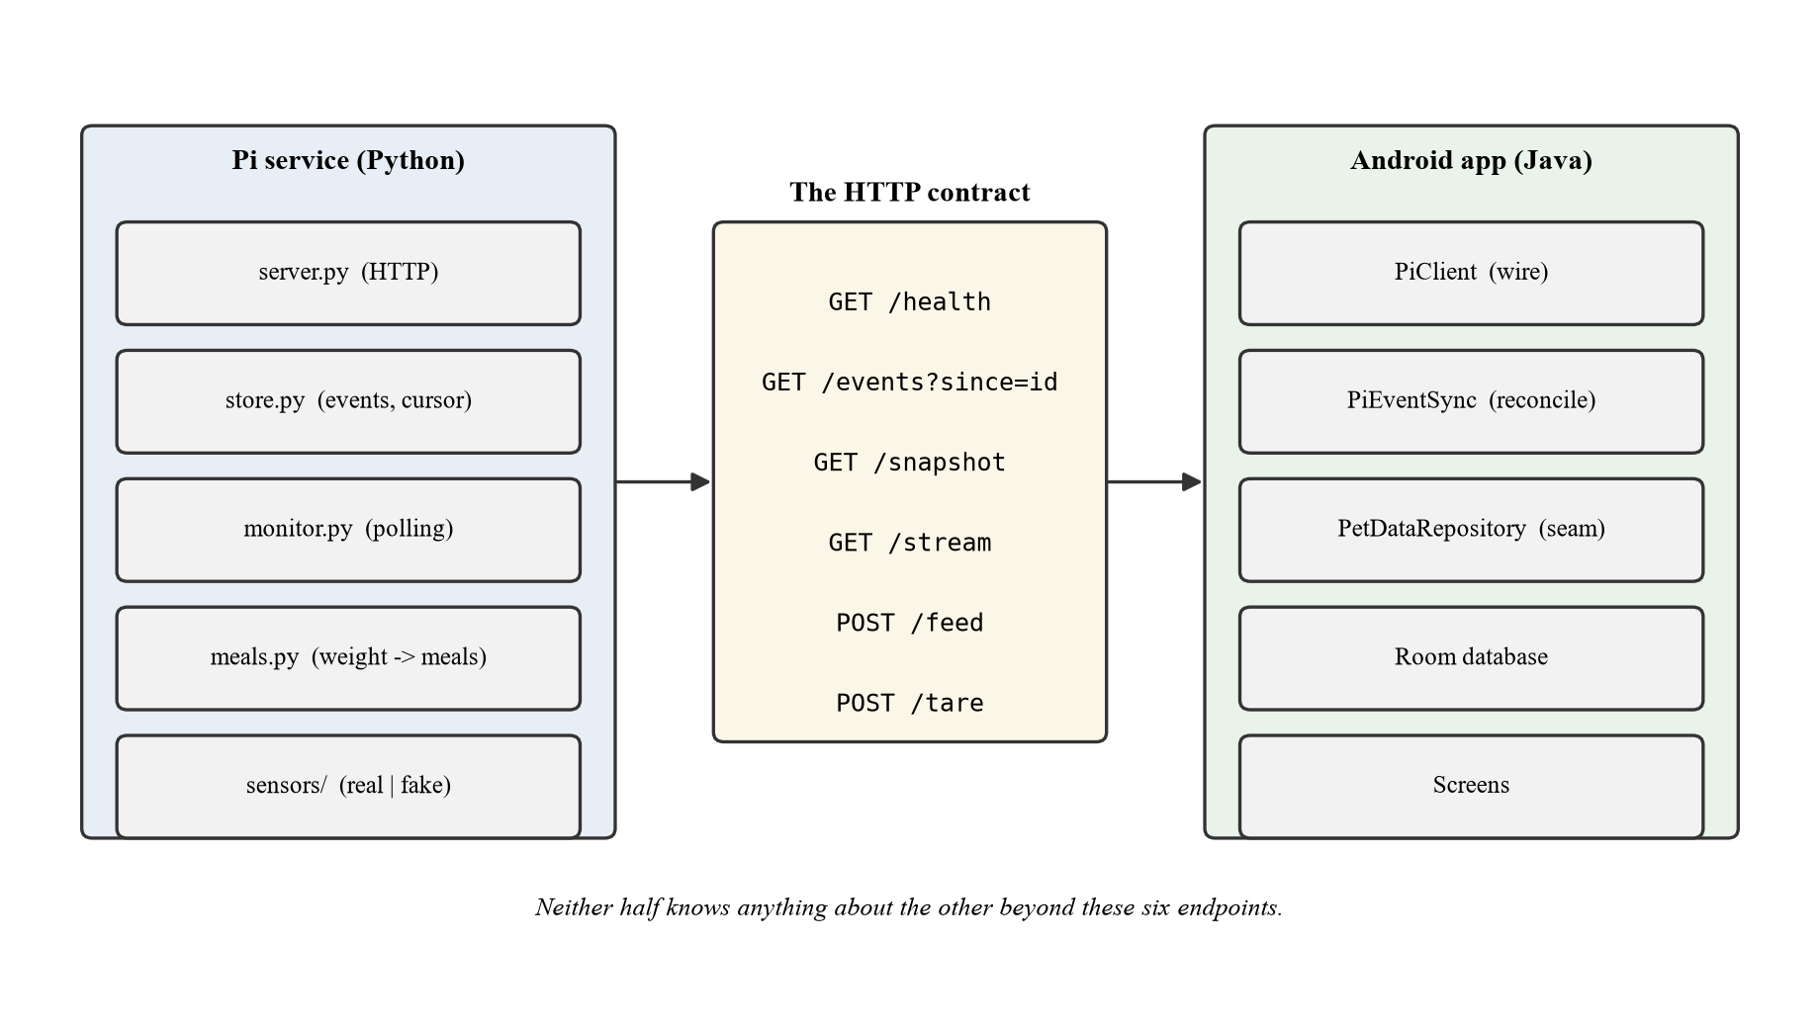
Figure 8: The two software halves and the six-endpoint contract between them.
Events come in four kinds: feeding, motion, weight and location. The contract states an evolution rule: adding a kind is safe and renaming one is not. The application skips unknown kinds rather than failing, so a newer Pi never breaks an older phone. Pages are capped at 500 events, and a single feed request is capped at 500 grams; both caps exist so that no single request, however unlucky, can stall a screen or empty a hopper.
The most consequential decision in the contract is the smallest one: the cursor is a database row id, not a timestamp. A client asks for “events after id 41,205”, not “events after 14:32:07”. The reason is the Pi's missing real-time clock, described in Section 2.1: the node's wall-clock time jumps forward by decades when NTP first synchronises after boot, so a timestamp cursor could skip everything recorded before the jump; and two readings in the same millisecond would be indistinguishable besides. A monotonically increasing row id has neither problem. The row id is meaningful only within one particular Pi's database, which creates its own hazard (a cursor pointing into a database that has been rebuilt), and Section 3.4 describes the two checks that defuse it.

3.3. The data model on the Pi
The Pi's entire persistent state is one append-only events table: id, kind, timestamp in milliseconds, a JSON payload, and a source string naming the device that produced the reading. There are no updates and no foreign keys; every observation is a new row, and rows older than thirty days are pruned. The database runs in SQLite's write-ahead-logging (WAL) journal mode because the sensor threads write while the HTTP thread reads, and WAL allows exactly that concurrency without either side blocking the other [11].
Append-only is not merely simple; it is the shape that survives synchronisation. Because a row, once written, never changes, delivering it twice is harmless if the receiver can detect the duplicate, and giving the receiver the means to do so is precisely what the next section describes.

3.4. The data model in the application
The application's Room database is at schema version 6 and holds five tables: pets, feeding_events, detection_events, room_events and tracker_fixes. Four hand-written migrations (2→3, 3→4, 4→5, 5→6) carry a user's data across schema changes, and each is validated by an instrumented test against the schema JSON that Room exports at build time. Destructive fallback, Room's option to wipe the database when no migration exists, is permitted only from version 1, which predates the schema export; every later version ships a real migration, so a schema change cannot silently destroy a user's pets. The last table's name is worth pausing on: the GPS reading is stored in tracker_fixes, as a TrackerFix with a trackerLatitude. The name says whose position this is at every level of the code, so nothing downstream can quietly repurpose the Pi's coordinates as the animal's.
Idempotent synchronisation is the mechanism that makes the whole buffering design safe, and Figure 9 shows one run of it. Every reading stored from the Pi keeps the Pi's own event id in a remoteId column, under a unique index on the triple (petId, source, remoteId), and inserts use Room's OnConflictStrategy.IGNORE. A re-delivered event therefore collides with its earlier self and is dropped rather than counted twice. This one index converts a dangerous operation into a free one: when the application detects that the Pi's event log was rebuilt, it can restart its cursor from zero and replay the entire history, and the replay is a no-op for everything already stored. Without it, “recover from a rewound cursor” and “double every meal recorded today” would be the same operation.
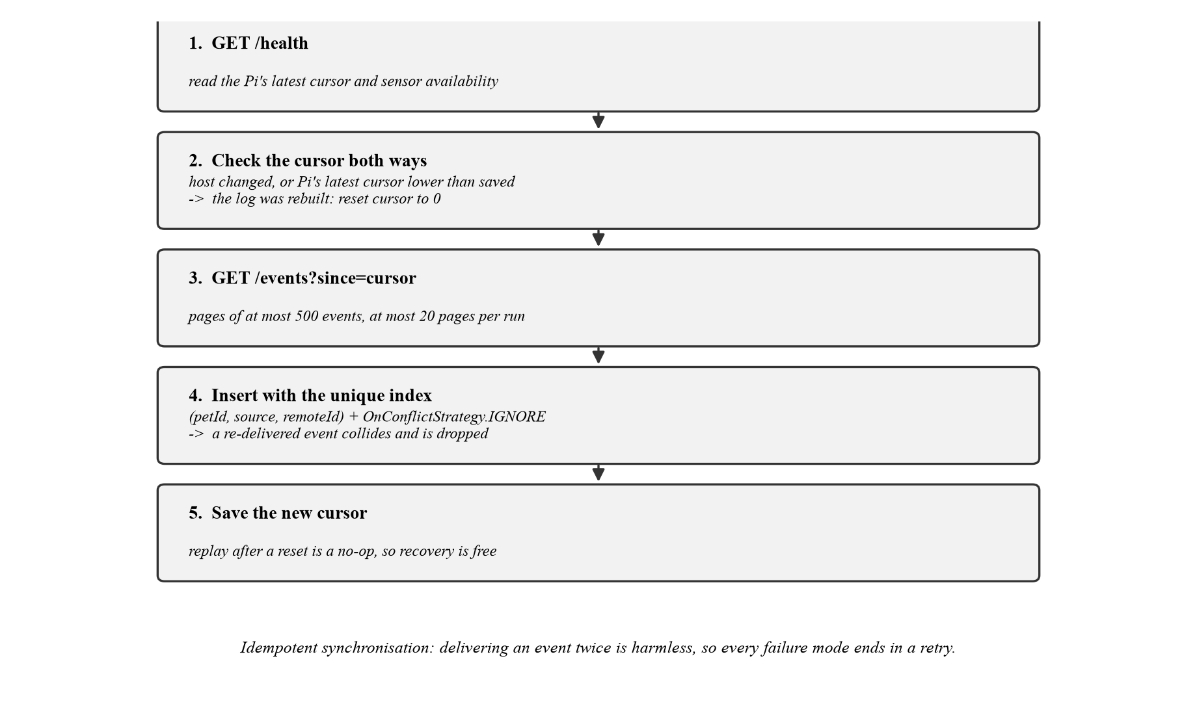
Figure 9: One synchronisation run. The unique index makes replay a no-op, so recovery is the same code path as an ordinary poll.
The cursor itself is checked in both directions on every synchronisation. It is reset when the saved host changes, since a row id in one Pi's database means nothing in another's; and it is reset when the Pi's /health reports a latest cursor lower than the one saved, which means that Pi's log was pruned or rebuilt. The second check matters more than it looks: without it, a phone whose cursor points beyond the end of a rebuilt log silently receives nothing forever, a failure that is indistinguishable, on the dashboard, from a quiet house.

4. The sensor node
This chapter describes the Python service on the Raspberry Pi: its structure, the signal processing that turns raw electrical readings into events worth storing, and its deployment as a supervised system service. The recurring theme is interpretation. A load cell produces a number twenty-five times a second and a PIR produces edges; a meal and a visit to the kitchen are judgements built on top, and each judgement in this chapter is stated with its thresholds and the reasoning behind them, because each is a claim the dashboard will eventually make to the owner.

4.1. Structure
The service is organised into small modules with one job each: server.py implements the HTTP contract; store.py owns the SQLite event buffer and the cursor; monitor.py runs the sensor polling loop; meals.py turns the weight series into meals; hx711.py speaks the load-cell amplifier's protocol; nmea.py parses GPS sentences; snapshots.py saves and serves camera frames; and bringup.py provides the hardware diagnostics described in Chapter 6. A sensors/ package separates interfaces (base.py) from real hardware (real.py), a full simulation (fake.py), a GPIO backend abstraction (gpio.py) and a self-recovering camera wrapper (camera.py). The simulation is not an afterthought: the entire service runs with --fake, which is how the application was developed before the rig existed and how the test suite runs on any machine.

4.2. Reading the load cell
The HX711 amplifier has no register interface; it is read by bit-banging a serial protocol. The Pi pulses the clock line and reads one bit of the 24-bit conversion per pulse, most significant bit first, with the number of trailing pulses selecting the gain (128 here) for the next conversion. The protocol has one critical constraint: holding the clock line high for more than 60 microseconds powers the chip down. That number turns an innocent-looking loop into a real-time problem on a multitasking operating system, because a Python GPIO call that dawdles for a tenth of a millisecond silently resets the converter mid-read.
Measured on this Pi, the gpiozero library could not toggle the clock fast enough to stay under the limit, while the lgpio backend held the clock high for only 3.7 µs. This drove a small but instructive piece of design in sensors/gpio.py: backend selection with a reversible preference order. Ordinary devices (a PIR is in no hurry) take whichever GPIO backend is available, but timing-critical devices request the preference order reversed so that lgpio is tried first. Raw readings are then median-filtered, and conversions that are saturated or all zero are rejected before they reach the weight series.

4.3. From weights to meals
The weight under the bowl is a noisy series that drifts with temperature and jumps when the animal leans on the bowl; a meal is a judgement extracted from it by meals.py under four rules, illustrated in Figure 10. A change smaller than 5 g is ignored. A change is committed only after the weight has held steady for 4 seconds; this settle time is what stops one meal from being recorded as five while kibble shifts and the animal nudges the bowl. Fluctuation within a 2 g band counts as noise, not change. And the baseline follows slow drift only after 30 seconds of stability, so thermal creep does not accumulate into phantom meals. At the calibrated scale factor of 385.66 counts per gram, the 5 g minimum change corresponds to roughly 1,900 counts, far above the converter's noise floor, so the thresholds and the electronics agree with each other.
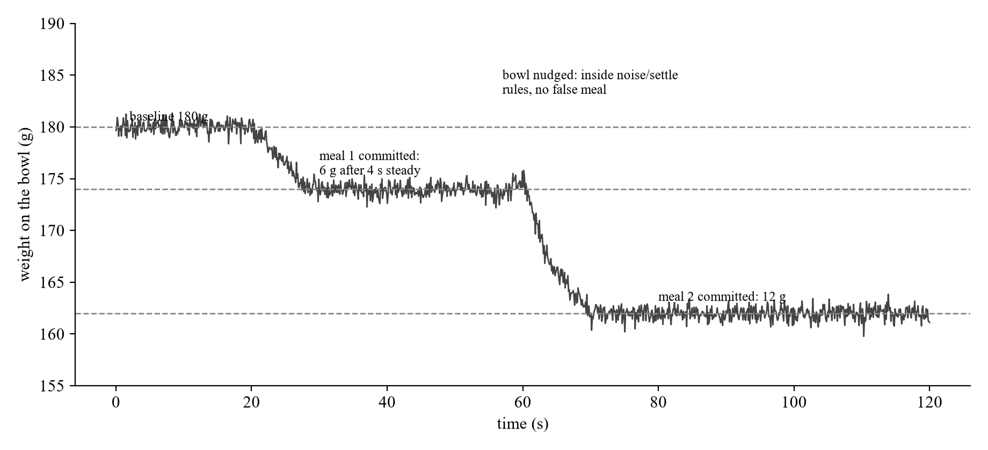
Figure 10: How the meal detector reads a weight series. Only changes that exceed 5 g and hold steady for 4 s become meals; a nudged bowl stays inside the rules.

4.4. From motion to rooms
A PIR reports movement, never presence. It fires while the cat crosses the kitchen and says nothing while the cat sleeps in it. The dwell model that turns sightings into a room chart therefore has to decide what a sighting is worth, and the rule is: each sighting speaks for the time until the next sighting anywhere, capped at 15 minutes (Figure 11). The cap is a judgement with reasoning on both sides. Too short, and a napping animal reads as spending time nowhere; too long, and the last sighting before bedtime credits the kitchen with the whole night. Fifteen minutes is comfortably past the node's 30-second per-room debounce, and short enough that a quiet house soon reads as “we no longer know”, which is the truth. The application draws the consequence on the dashboard: it distinguishes no sensors reporting, sensors reporting but quiet today, and “no motion since 09:12”, and it never claims the pet is still wherever it was last seen.
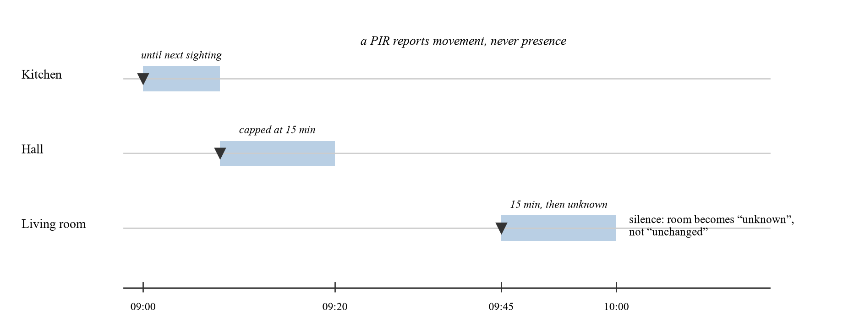
Figure 11: The dwell model. A sighting speaks until the next sighting anywhere, capped at 15 minutes; after that the room is unknown, not unchanged.

4.5. GPS parsing
The GPS module streams NMEA sentences continuously. The service parses GGA sentences, validates each with its XOR checksum, converts coordinates from NMEA's degrees-and-decimal-minutes format to decimal degrees, and checks the fix-quality field so that a receiver that is talking but has no satellite solution is never mistaken for one with a position [7]. Valid fixes are logged every five minutes as location events. The distinction between “the module is silent” and “the module is talking but knows nothing” is instrumented explicitly in the bring-up tooling, and Chapter 7 shows that distinction earning its keep during a hardware fault.

4.6. The camera service
The node captures JPEG frames from either camera, serves a live MJPEG stream over /stream, and saves a snapshot on each motion event so the application can show what the camera saw when the room lit up. Cameras fail differently from other sensors: a camera that worked yesterday can be held open by another process, unplugged, or left in an undefined state by a crashed reader. The ReopeningCamera wrapper accepts that reality. After three consecutive capture failures it closes and reopens the device, at a rate limit rather than in a tight loop, so a genuinely absent camera produces a calm rhythm of retries instead of a hammering that would bury the log and starve the bus.

4.7. Deployment
The service runs under systemd, started at boot, with Restart=always and a restart delay of five seconds; the delay is chosen so that a genuinely broken configuration appears in the journal as a visible restart loop rather than being hidden by instant retries [12]. It runs as an unprivileged user whose home directory holds the database and who belongs to the gpio and video groups; no part of the system requires root at runtime.
All tuning lives in one environment file, service.env, which survives a reinstall and needs no root to edit: room names and their PIR pins, camera type, GPS port, scale pins and calibration factor, feeder kind, servo pin and the paddle parameters. Appendix B lists every variable. One cross-platform detail earned its place in the installer: it strips carriage returns from the environment file, because the source is edited on Windows and copied with scp, a byte-for-byte transfer. Without that, systemd reads PETTRACKER_CAMERA as usb\r and the service fails complaining about an unknown camera called “usb”, with the offending character invisible in every place one would look for it.

5. The mobile application
The Android application is the half of the system the owner actually touches. This chapter describes its structure, the authentication and storage layers, the synchronisation client, and, most importantly, the discipline imposed on its screens: every screen states only what a sensor measured, and the wording, the data model and the empty states are all built to keep that promise.

5.1. Development environment and structure
The application was developed in Android Studio in Java. Java was chosen over Kotlin for my own fluency in it; the Android framework supports it fully. The codebase is 6,531 lines across 45 classes and 13 layouts, and its dependencies each earn their place: Room for local persistence, Firebase Authentication for accounts, Material Components for the interface, Glide for image loading off the main thread, and CameraX with the TensorFlow Lite Task Vision library for on-device object detection [13, 14, 15]. Notably absent is any HTTP client library: the application speaks to the Pi through the platform's own HttpURLConnection, because two small GET requests against a device on the same LAN do not justify a dependency stack that must be kept current.
The classes group into four layers (authentication, navigation and screens, the data layer, and vision/streaming) with strict threading discipline throughout: every database and network operation runs on a worker thread, results return to the main thread for rendering, and each callback is guarded against the activity having been destroyed in the meantime. Figure 12 shows how the screens connect.
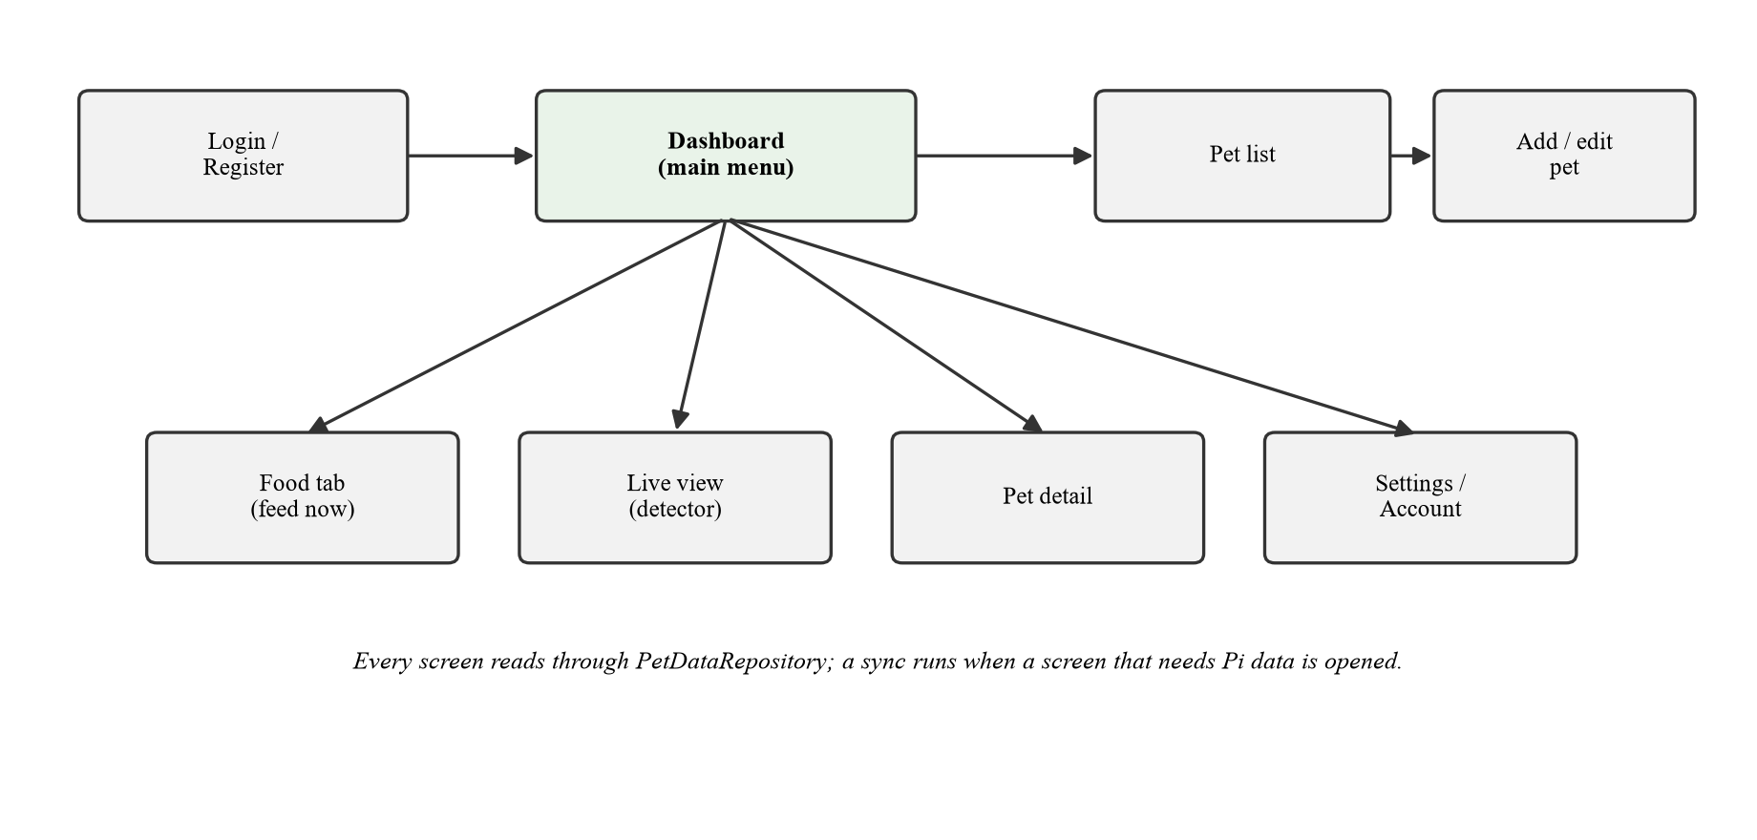
Figure 12: The application's screens and navigation. Every screen reads through the repository seam.

5.2. Authentication
Every pet record belongs to an owner, so the application must know who is using it. Rather than building a password database and the hashing, reset and abuse-protection machinery around it, the project delegates the entire concern to Firebase Authentication [15]. Registration and login are thin screens over the Firebase SDK with client-side validation; a logged-in session persists across launches until the user signs out; and the account screen offers a password reset through Firebase's emailed single-use link. Every database query in the application is filtered by the current Firebase user id, so multiple people can share one physical device (a couple sharing a tablet, for example) without ever seeing each other's pets. This isolation is enforced at the query level: deleting a pet requires both the pet's id and the owner's id, so a stale object can never remove someone else's row.

5.3. Local persistence and migrations
The pets table stores each animal's profile: name, species, breed, weight, sex, birthdate, notes, photo and owner. The four event tables described in Section 3.4 store what the sensors reported. The schema-migration discipline deserves emphasis because it is where an early version of this project carried a real hazard. The original database was built with Room's fallbackToDestructiveMigration(), meaning any schema version bump silently deleted every pet on every device. The current design exports the schema to JSON at build time, commits that JSON as a baseline, ships a hand-written migration for every version step since, and drives each migration through real SQLite in an instrumented test that validates the result against the exported schema. A typo in a migration's CREATE statement now fails on a test device before it can fail on a phone whose pets are already gone.

5.4. The repository seam and the synchronisation client
One class, PetDataRepository, is the seam the whole integration passes through. Every reading enters the database through it and every screen reads through it; nothing above it knows whether a reading came from HTTP, a socket or a message broker. This is what made joining the two halves a bounded change: when the Pi integration landed, it arrived as three classes behind the seam (PiClient for the wire, PiEventSync for the reconciliation judgement, PiSync to run it for a screen) and not a single screen changed.
Synchronisation is foreground-only, deliberately. Background polling on Android requires either a foreground service with its permanent notification, or WorkManager with its fifteen-minute floor. These are real costs in battery and in the notification shade, and they would buy nothing here, because the Pi buffers every reading and hands over whatever was missed the moment the application opens: nothing is lost by not listening, so nothing listens. The note in the project's decision log records where this trade-off flips. Push notifications (“Biscuit has not eaten today”) are the feature that would make background synchronisation earn its keep. A synchronisation run is also bounded: at most 20 pages of 500 events each, so a month of unsynchronised history cannot stall the screen that innocently triggered the catch-up.

5.5. What the screens say
The screens are where the design principle of Section 1.2 becomes visible, and each of the following is a deliberate instance of it rather than a stylistic accident.
- The dashboard renders null grams and 0 grams differently: null means no feeder paired, zero means paired, and the pet ate nothing. The first is ignorance; the second is a measurement.
- “No motion sensors reporting” and “sensors reporting, no motion” are separate sentences, because they are different facts with different remedies.
- The detection card is labelled “live view only”, because the object detector runs on the phone, and only while the Live screen is open. The count is “what was seen while watching”, not the day's total, and saying otherwise would claim coverage the system does not have.
- The “camera live” indicator derives from the Pi's /health endpoint within a two-minute freshness window, not from whether the phone's detector recently saw an animal, which is only ever true while somebody is watching.
- Requesting a feed records nothing. The request says what was asked for; only the load cell knows what fell, and the meal arrives on a later poll, weighed. Recording the request as a feeding would put an unverified number on the dashboard.
- The GPS reading is labelled “Pi located”, never as the pet's position, with the coordinates and satellite count available behind a tap. The naming runs through the schema itself (tracker_fixes, TrackerFix, trackerLatitude), so no future code can quietly repurpose it.
- “Available”, for any sensor, means the sensor can do its job, not a library claimed a handle.
One rule sits beneath all of these: timestamps before 1 January 2020 are discarded. A Pi with no real-time clock genuinely believes it is 1970 between boot and NTP synchronisation. Readings stamped in that window cannot be placed on any real day, so they are dropped. They are not filed under January 1970, and not moved to “now”, which would invent a meal that never happened.

5.6. Live streaming and detection
The live screen shows the Pi's camera as an MJPEG stream, a long HTTP response of JPEG frames, parsed by a small custom MjpegInputStream that scans for the JPEG start-of-image and end-of-image markers rather than trusting the multipart boundary, which makes it robust to any server that emits well-formed frames. MJPEG is bandwidth-hungry compared to modern codecs, but every Android device decodes JPEG natively and the stream never leaves the home network, so the trade is a good one.
Each frame can be passed to an on-device object detector: EfficientDet-Lite2 [1] running through the TensorFlow Lite Task Vision library [14], with a score threshold of 0.40 and at most ten results per frame. Detections are filtered to the animal classes of the COCO taxonomy [2] before anything is recorded (a sofa is not a pet sighting) and throttled to one stored row per label per 30 seconds, because at fifteen frames per second an unthrottled recorder would write tens of thousands of rows an hour that say nothing new. A back-pressure flag ensures a new frame is only submitted when the previous inference has finished, so the detector can never build an unbounded queue behind a fast network.

6. Testing and verification
The project is guarded by 376 automated tests in three suites, each with a different purpose and a different execution environment, summarised in Table 3. Beyond the suites, two further verification ideas turned out to matter as much as the tests themselves: treating hardware bring-up diagnostics as a design feature, and putting the deployment configuration itself under test.
Suite | Count | Runs on | Covers
Pi (Python) | 218 | Any machine, no hardware | Protocols, parsing, event store, feeders, HTTP
Android unit (JVM) | 59 | Laptop | Wire format, HTTP client, date windows, MJPEG parsing
Android instrumented | 99 | A real phone | Room migrations, repository, sync, layouts, theming
Table 3: The three test suites. All 376 tests pass.

6.1. Fakes as first-class citizens
The sensors/fake.py module lets the entire Pi service run with --fake: simulated motion, a simulated weight series that eats meals, a synthetic camera. This is what allowed the application to be developed against a complete, working “rig” months before the physical rig existed, and it is why 218 Pi tests run on any machine. The fakes implement the same interfaces as the real sensors, so the service cannot tell the difference, which also means the seam between interpretation and hardware is real, not aspirational.
Some tests deliberately cross seams instead of isolating them. PiClientTest drives the HTTP client against a real socket serving the documented JSON, including a 500 response, an HTML page (someone typing their router's address into the host field), and a connection cut mid-reply. PiSyncIntegrationTest runs the whole chain on the device, from saved address to URL to HTTP over a socket to the cursor in preferences to work off the main thread and the answer back on it, because the seams are where synchronisation fails and no unit test crosses them. RoomOccupancyTest pins the dwell rule of Section 4.4, which is a judgement rather than a fact: what a sighting is worth, when a visit starts, and that silence makes the pet's room unknown rather than unchanged.

6.2. Bring-up diagnostics as a design feature
The node ships a diagnostics module, bringup.py, with a check for every sensor: --check-motion, --check-scale, --calibrate-scale, --check-gps, --check-servo and --check-camera. The justification belongs in any methodology chapter: the /health endpoint answers “did the library claim the pin”, which is not the same question as “is the sensor wired the right way round and pointing at the right room”. A PIR whose output is connected to the wrong GPIO is indistinguishable, in the event log, from a cat that never goes into the hall. No automated test can close that gap, because the fault is in the relationship between the physical world and the configuration. So the tooling lets a human stand in a room, wave, and confirm that the right room's name lights up: one line per sensor, live, with a summary naming the likely cause for any sensor that never fired.
Chapter 7 shows this tooling doing its real job: three of the six incidents were diagnosed primarily by a --check- tool, and in two of them the tool's ability to distinguish failure modes, not just success from failure, is what located a hardware fault without laboratory equipment.

6.3. Configuration under test
The most unusual suite member is test_service_unit.py, which tests the systemd unit file. It does what systemd does (reads the Environment= defaults, splits ExecStart into words, expands ${VAR} per word) and feeds the result to the real argument parser, extracted for the purpose. A unit file that passes a flag the program does not have now fails on a laptop in a second, instead of exiting with status 2 into the journal on the Pi at boot. The suite also asserts that the unit's default values equal the code's defaults, which is what makes their deliberate duplication safe: the unit file is meant to be readable on its own, and a unit saying 30° while the code means 45° is a paddle parking in the wrong place with nothing anywhere disagreeing. The test was verified to fail as well as to pass; changing one default produced exactly one failure naming it.
A companion test, test_sources_compile.py, compiles every Python source file and runs the entry point with --help. Why such a trivial test exists at all is one of Chapter 7's incidents; the short version is that the one file no test imports is the one file a user actually types.

6.4. Verification on real hardware
Automated tests bound the software's behaviour; the system claim, sensor to screen, was verified on the physical rig. On 30 August 2026, with the service running under systemd on the Pi in the hallway and the application on a physical Android phone (a TECNO CI7n), the following were confirmed by hand: all three PIRs firing and mapped to their correct rooms; events surviving a service kill and restart via the SQLite buffer; the application collecting buffered events and drawing the room chart; the dwell rule showing “no motion since 15:23” against stale motion rather than claiming a room; snapshots appearing on the room card; the live stream feeding the phone's detector; the load cell reporting grams through /health after calibration; the GPS fix stored and displayed as “Pi located”; and the feeder dispensing from the Food tab. The distinction between emulator-verified and device-verified turned out not to be pedantry, as the next chapter's fifth incident demonstrates.

7. Engineering incidents
A project narrative with no failures reads as fiction. This chapter documents six real faults encountered during development and bring-up: what was observed, how each was diagnosed from evidence, and what each generalises to. They are presented in full because they carry more transferable engineering content than any feature description. Every one of them changed the shape of the system, and in four of the six the diagnostic tooling built to find the fault outlived the fault itself.

7.1. The dead amplifier, found by software
The HX711 returned all zeros. Nothing distinguishes this, at first sight, from a dozen software causes, so the investigation eliminated them in order. Was another process holding the pins? Busy-pin detection was added: no. Was the bit-banged protocol violating the 60 µs clock-high limit of Section 4.2? A clock-speed probe was added, and it found a real problem: gpiozero was indeed too slow, and the backend was switched to lgpio at 3.7 µs. But the zeros persisted, so the timing fault was real yet not the fault. Were data and clock swapped? An automatic pin-swap probe was added, reading both orientations: still zeros. Only after every software explanation was eliminated was the amplifier declared electrically dead, and the cause then surfaced from memory: the board had once been powered with VCC and GND reversed, which these boards do not survive and do not visibly show. The module looked perfect; the data line simply never drove again.
A replacement HX711, wired with the polarity checked twice, worked immediately and calibrated cleanly. The lesson is in what remained afterwards: the busy-pin detection, the timing probe and the pin-swap probe all ship today inside --check-scale. The diagnostic tooling built to find the fault outlived the fault, and the next scale problem, anyone's, will be triaged in minutes by a tool that names which of three silences it is seeing.

7.2. The wrong antenna, found without a spectrum analyser
The GPS module produced a constant stream of well-formed NMEA sentences and never a fix, with the satellite count stuck at zero. The naive readings of this symptom (dead module, bad wiring, wrong serial configuration) were all wrong, and they were exonerated immediately, because --check-gps had been built to distinguish “the module is silent” from “the module is talking but knows nothing”. A silent module points at wiring or the port; a talking module that knows nothing has power, ground, a correct TX line and a working serial link, and simply cannot hear the sky. The remaining suspect was the antenna, and inspection confirmed it: the attached antenna was a 2.4 GHz Wi-Fi antenna, visually near-identical and electrically deaf at GPS frequencies, on a receiver listening at 1575.42 MHz. With a correct active GPS antenna, the module fixed from twelve satellites without further drama.
The lesson: instrument the difference between failure modes, not just the difference between success and failure. A checker that reported only “no fix” would have left all hypotheses standing, and distinguishing them by trial replacement would have needed parts and days. The distinction between silences cost perhaps ten lines of code and replaced a spectrum analyser.

7.3. The invisible configuration bug
The service exited at startup with status 2, complaining: “2 room(s) but 3 pin(s)”. Both settings were correct, three rooms and three pins, and staring at either one led nowhere, because the fault was in neither. systemd splits an Environment= value on whitespace, so the unquoted line PETTRACKER_ROOMS=Kitchen,Living room,Hall delivered Kitchen,Living as the variable's value and discarded the rest [12]. Two rooms, three pins: the error message was factually accurate about a configuration nobody had written, and pointed at the wrong setting entirely. The fix was one pair of quotation marks; the protection is the unit-file test of Section 6.3, which expands the environment exactly as systemd does and would now catch the truncation on a laptop. A sibling hazard was noted while fixing it: in ExecStart, systemd expands ${VAR} and $VAR with different word-splitting rules, and the wrong choice fails the same way, silently.
The lesson: when an error message names a setting, the fault may live in the machinery that delivered the setting, and configuration languages have parsers with opinions of their own. Configuration that cannot be tested is configuration that fails at boot, on the device, in the journal.

7.4. A syntax error that survived a green test suite
A version of run.py, the service's entry point, was committed and pushed containing a syntax error. The test suite was green before the push and green after it. The file was unparseable Python, and 218 tests had no opinion, because run.py was the one file no test imported: every test exercised the modules behind the entry point. The fault was found by running the service by hand, which is to say it was found late, on the Pi. The fix is the trivially simple test_sources_compile.py: compile every source file, and run run.py --help to prove the entry point at least assembles its argument parser.
The lesson generalises beyond Python: coverage measured over what the tests import is blind to entry points, and the file a user actually types is the file most worth protecting. The gap is invisible precisely because entry points look too thin to test. All they do is wire together the parts that are tested, and yet they are the single point through which every user reaches those parts.

7.5. The emulator was hiding a broken test fixture
The 99 instrumented tests had been passing on the Android emulator for weeks. Run for the first time against a real phone, 55 of them failed immediately with no such table: pets. The application was innocent; the defect was in the test fixture. Each suite deleted the database file between runs while a cached Room singleton still held an open connection to it. The emulator's filesystem handling of a deleted-but-open database file was lenient enough to mask the misuse; the real device's was not, and the suites collided with their own stale connections. The fixture was corrected to close the database before deleting it, after which both environments agreed.
The lesson: emulated verification and real-device verification are not interchangeable, and a green suite can be green because the environment is forgiving rather than because the code is right. The honest account of this project's testing is therefore not “the instrumented suite always passed”. It is that the suite passed on the emulator, failed at scale on first contact with hardware, and the failure was informative.

7.6. The failure mode of a camera that worked yesterday
Only one process may hold a CSI camera. A second copy of the service, most easily created by starting one by hand next to the one systemd is already supervising, takes the camera, and the first copy then produces a fault that looks exactly like broken hardware: the camera that streamed yesterday returns errors today, with no wiring changed. Once understood, the failure was handled rather than merely avoided: the ReopeningCamera wrapper described in Section 4.6 retries at a rate limit after three consecutive failures, so the service degrades gracefully and recovers by itself when the camera becomes free, rather than hammering a device it cannot have.
The lesson is about exclusive resources generally: any resource that only one process may hold will eventually be held by the wrong one, usually by an operator's own hand during debugging, and the recovery path deserves design attention precisely because the fault will be misread as hardware.

8. Results
This chapter collects the measured results of the project. Every value in Table 4 was produced by the real system, by the bring-up tools, the health endpoint, or the test runners, and none is an estimate. Figures that were not measured are conspicuously absent by design: the project produced no latency, battery, power-draw or detection-accuracy measurements, and Chapter 10 lists that among its limitations rather than allowing an approximation to stand in.
Measurement | Value | How obtained
Load cell calibration | 385.66 counts/g | 614.4 g reference; two independent runs agreeing to 0.65%
Load cell zero stability | −0.04 g after tare | /health, with servo and buck converter sharing ground
Load cell headroom | 5 kg ≈ 1.9 M counts | vs the HX711's ±8.4 M range (no saturation)
HX711 clock-high time | 3.7 µs (lgpio) | Timing probe; must stay under 60 µs; gpiozero failed this
GPS fix | 12 satellites, 32.00964, 35.76567 | --check-gps
CSI camera | 20/20 frames, 18.4 fps | --check-camera
Motion sensors | 3 of 3 firing, correct rooms | --check-motion
Automated tests | 376 (218 + 59 + 99) | All passing
Codebase | 6,531 lines Java; 4,737 lines Python | 45 classes, 13 layouts
Development span | 2026-04-29 → 2026-08-30 | 54 commits
Table 4: Measured results. Every value was produced by the real system; none is an estimate.

8.1. Calibration methodology
The scale factor deserves a note on method, because the errors made and corrected along the way are themselves a result. The first calibration used a phone of assumed weight, an assumption rather than a measurement. The second used a 600 ml bottle of water as a 600 g reference, and produced a factor that was then discovered to be 2.4% high: the bottle's own 14.4 g of plastic had been included in the load but excluded from the declared mass. The error was recovered without recalibrating, by weighing the empty bottle on the newly calibrated scale and correcting the declared reference. The final factor, 385.66 counts per gram, is the mean of two independent runs agreeing to 0.65%.
The general point is worth stating: any error in the knowledge of the reference divides straight into the calibration factor, and from there into every measurement the instrument will ever make. It is also why a heavier reference is preferable to a lighter one; the same absolute uncertainty in the reference is a smaller relative error in the factor. After calibration, the zero sat at −0.04 g following a tare, measured with the servo and its buck converter live and sharing the Pi's ground, which simultaneously verified that the feeder's power topology of Section 2.4 does not disturb the measurement chain.

8.2. The system claim
The headline result is not any single number but the verified chain: a paddle wheel commanded from a phone dispenses food; the load cell weighs what actually fell; the meal detector turns the weight series into a meal; the event store buffers it; the application collects it, deduplicates it and files it under the correct local day; and the dashboard reports it. Meanwhile a quiet motion sensor upstairs correctly reports “no motion since 15:23” instead of a guess, and the GPS card correctly claims to know where the tracker is and nothing more. Every link in that sentence was exercised on real hardware on 30 August 2026.

9. Discussion
Two things in this project are worth defending at greater length than a feature list allows: the principle that shaped every screen, and the alternatives that were considered and turned down. Both are discussed here, the first because it is a stance an examiner can push against, the second because a design is defined as much by its refusals as by its features.

9.1. The design principle: state only what was measured
The single thread running through the whole system is the rule stated in the introduction: every screen states only what a sensor actually measured, and “no data” is never rendered as zero. Section 5.5 listed seven concrete instances; here I want to defend the rule itself, because it has costs, and a designer who adopts it must be prepared to pay them.
The cost is that the honest system almost always appears to know less than a dishonest one would. A dashboard willing to render a dispense request as a meal would show food data on day one, feeder connected or not. A room card willing to extrapolate would always name a room, and be wrong silently; ours says “no motion since 09:12” and looks more ignorant for it. A detection count presented as “today's sightings” reads better than one labelled “live view only”. In every case the dishonest rendering is easier to build, demos better, and fails only later, quietly, when a user makes a decision (has the cat eaten?) on a number that was never a measurement.
The claim this thesis defends is that for a monitoring system the trade is not close. A monitoring system has exactly one product: statements the owner can act on. Its value collapses not when it knows little, but when what it says cannot be trusted, and unlike missing data, misplaced trust does not announce itself. The rule also proved to have engineering value beyond ethics: it forced the distinction between null and zero into the data model, which is what made the empty states testable (a dedicated test pins “not reporting” versus “reported zero” apart); it forced the naming of tracker_fixes, which structurally prevents a future feature from mispresenting the Pi's position as the animal's; and it forced the timestamp rule that keeps 1970-stamped readings from inventing history. Honesty, imposed as a constraint, kept turning into architecture.
The rule's strongest test is the feeder. The system commands the feeder and could trivially record what it commanded; it records nothing, because a hobby servo has no feedback and the command is not a measurement. The meal appears only when the load cell weighs it. This is the principle at its most expensive (a user who feeds sees no immediate number) and its most defensible: the number that appears minutes later is true.

9.2. Roads not taken
MegaDetector instead of EfficientDet-Lite2. MegaDetector [3] is the strongest available detector for camera-trap-style animal imagery, and it was investigated seriously. It was rejected for this deployment on two grounds. First, it is a detector of animals-versus-everything and would still need a separate species classifier behind it. Second, and decisively, the Pi's runtime environment made it a fight rather than a feature: neither onnxruntime nor tflite_runtime was installable on the target OS, whose Python environment is externally managed under PEP 668 [16]. The stated priority stands: demonstrating that the application works matters more than making everything expandable.
A camera in every room. Deferred, not designed away. The current pair costs nothing in bandwidth because the two cameras sit on separate buses; a third camera would mean USB contention or another host, and a Pi 4 has one CSI connector. The room chart therefore runs on PIRs, which are a few euros per room.
Cloud synchronisation. Held for evaluation rather than rejected. The local layer was deliberately built into the shape that syncs well: append-only rows, explicit timestamps, explicit source, stable remote ids. Cloud replication therefore remains a clean addition rather than a rewrite. The counterweights are real: free-tier quota against detection volume, security rules, and an offline/conflict story that deserves design rather than improvisation.
Background polling. Rejected with reasoning given in Section 5.4: it would cost a permanent notification or a fifteen-minute scheduling floor and buy nothing while the Pi buffers. Nothing is lost by not listening, so nothing listens. Push notifications are the recorded point at which this decision should be revisited.
HTTP client libraries, on either side. Both halves use their platform's own HTTP machinery. Two GETs against a device on the same LAN do not justify a dependency stack that must be kept current, and on the Pi side this is one instance of the broader standard-library-only constraint, which Chapter 4 argued is a reliability feature for an unattended device.

10. Limitations and future work
The faculty's guidance asks that unmet targets be communicated bravely and unambiguously. This chapter does so. Each limitation below is real; for each I state whether it is a consequence of a design decision, a measurement not yet taken, or work not yet done.

10.1. Limitations
- A PIR detects movement, not identity. The system cannot distinguish between two animals, nor between an animal and a person, from motion alone. In a multi-occupant home the room chart records the household's motion, attributed to the active pet.
- The GPS locates the tracker, not the pet. The pet's position within the home comes from the motion sensors; the GPS proves the location subsystem works end to end. Tracking the animal itself outdoors would require a collar-borne tag, which is a hardware project of its own.
- Detections accumulate only while the Live screen is open, because the detector runs on the phone. The interface says so explicitly, and no daily total is claimed.
- The feeder has no feedback. A hobby servo has no position sensor, so neither half of the system knows whether the wheel turned. The load cell is the only ground truth for what was dispensed.
- Transport is plain HTTP on the LAN, with no TLS and no authentication: anyone on the home network can read the endpoints and operate the feeder. This is acceptable for a prototype on a private network and is named here as a real limitation. A network-security-config cannot express “allow cleartext to whatever address the user typed”, so the honest options are pinning the saved address into a generated config, or HTTPS on the Pi with a self-signed certificate and a trust anchor in the application.
- Single-pet focus. The data model supports many pets, but synchronisation attributes readings to the one active pet.
- One calibration constant is still a placeholder: grams-per-pocket for the paddle feeder (PETTRACKER_PADDLE_GRAMS) must be measured with a full hopper, because the column of kibble above the wheel is what fills the pocket. Until then, portion counts are configuration, not measurement.
- No latency, battery, power-draw or detection-accuracy figures were measured. Table 4 is the complete list of measured values; this thesis makes no performance claims beyond it.

10.2. Future work
The natural next steps follow from the limitations. Push notifications are the feature that would justify background synchronisation, and the two should land together. Cloud replication of the event tables would un-bind a user's data from one device, and the local schema was shaped so that this remains an addition rather than a rewrite. A collar-borne position or accelerometer tag would give the system the animal's own location and activity, at which point the tracker_fixes table would gain a sibling rather than a new meaning; the naming discipline of Section 5.5 was chosen precisely so that day requires no renaming. Identity, meaning which pet was seen, is the hardest and most interesting extension, requiring either per-animal tags or a species-and-individual classifier behind the detector; nothing in the current system claims it, so nothing needs unsaying when it arrives. Finally, the retention of the application-side event tables is currently unbounded; wiring the existing deletion queries to a retention window is small, deliberate housekeeping awaiting real data volume to reason about.

11. Conclusion
This thesis set out to build and verify a pet monitoring system end to end: a Raspberry Pi sensor node that buffers observations locally, and an Android application that reconciles them idempotently, joined by a six-endpoint HTTP contract and constrained everywhere by one rule: say only what a sensor measured. The system was built, and the claim was verified on real hardware. On 30 August 2026, every sensor on the rig was live and every reading reached the phone, from three motion sensors, a calibrated load cell, a GPS receiver with a twelve-satellite fix, and two cameras, with the feeder dispensing on command from the application and the resulting meal arriving weighed, minutes later, as a measurement rather than an assumption.
The technical contributions I would defend most readily are the small decisions with long consequences. A cursor that is a row id rather than a timestamp, because the node has no real-time clock. An idempotency index that makes replay free, so recovery from a rebuilt log is the same code path as an ordinary poll. A dwell model that lets silence mean “unknown” rather than “unchanged”. A feeder whose current cannot pass through the computer recording its meals. A configuration file that is itself under test, expanded exactly as systemd would expand it. None of these is individually large; together they are why the system survives reboots, network absences, log rebuilds and its own operator.
The project also kept its failures, and Chapter 7 argued they are worth more than the features. A dead amplifier was identified by eliminating every software explanation first, and the elimination tooling now ships as a diagnostic. A wrong antenna was identified without radio equipment because the tooling distinguished two kinds of silence. A configuration bug survived inspection because the error message pointed at the wrong setting; a syntax error survived a green suite because no test imported the entry point; an emulator concealed a broken fixture that a real phone exposed in fifty-five simultaneous failures. Each incident hardened the system, and each generalises beyond it.
Not every target was met, and the shortfalls are stated plainly in Chapter 10 rather than argued around: transport on the LAN is unsecured, one feeder constant awaits measurement, no performance figures were taken, and the system neither identifies individuals nor tracks the animal beyond the home. I consider the honest accounting of these gaps to be part of the work, not a deduction from it; it is the same discipline the dashboard applies to a missing sensor, applied to the thesis itself.
What I take from the project, beyond the artefact, is a working method: bring up hardware with tooling that distinguishes failure modes; put judgement into named, tested modules and keep it out of screens; treat the configuration and the entry point as code worth testing; and never let the interface claim coverage the sensors do not have. The system now sits in a hallway, watching for a cat, saying exactly as much as it knows, and nothing more.

Bibliography
Books, articles and papers
[1] Tan, M., Pang, R., Le, Q. V.: EfficientDet: Scalable and Efficient Object Detection. Proceedings of the IEEE/CVF Conference on Computer Vision and Pattern Recognition (CVPR), 2020, pp. 10781–10790.
[2] Lin, T.-Y., Maire, M., Belongie, S., Hays, J., Perona, P., Ramanan, D., Dollár, P., Zitnick, C. L.: Microsoft COCO: Common Objects in Context. European Conference on Computer Vision (ECCV), Springer, 2014, pp. 740–755.
[3] Beery, S., Morris, D., Yang, S.: Efficient Pipeline for Camera Trap Image Review. arXiv:1907.06772, 2019.
[4] Monk, S.: Raspberry Pi Cookbook, 3rd edition. O'Reilly Media, 2019.
[5] Vogel, L., et al.: Android Development: Tutorials on Activities, Room and Background Processing. vogella GmbH, 2023.
[6] Upton, E., Halfacree, G.: Raspberry Pi User Guide, 4th edition. Wiley, 2016.
Standards, datasheets and documentation
[7] u-blox AG: NEO-M8 series data sheet; NMEA 0183 protocol as implemented in u-blox GNSS receivers, Receiver Description and Protocol Specification. https://www.u-blox.com/en/docs (accessed August 2026).
[8] AVIA Semiconductor: HX711, 24-Bit Analog-to-Digital Converter (ADC) for Weigh Scales. Datasheet. https://cdn.sparkfun.com/datasheets/Sensors/ForceFlex/hx711_english.pdf (accessed August 2026).
[9] HC-SR501 PIR Motion Detector: Product Description and Datasheet. https://www.mpja.com/download/31227sc.pdf (accessed August 2026).
[10] Raspberry Pi Ltd: Raspberry Pi Documentation: GPIO, Camera, and Remote Access. https://www.raspberrypi.com/documentation/ (accessed August 2026).
[11] SQLite Consortium: Write-Ahead Logging. https://www.sqlite.org/wal.html (accessed August 2026).
[12] freedesktop.org: systemd.service, systemd.exec: systemd manual pages. https://www.freedesktop.org/software/systemd/man/ (accessed August 2026).
Internet sources
[13] Google LLC: Android Developers: Room persistence library; CameraX; Activity Result APIs. https://developer.android.com/ (accessed August 2026).
[14] Google LLC / TensorFlow: TensorFlow Lite Task Library: Object Detection. https://www.tensorflow.org/lite (accessed August 2026).
[15] Google LLC: Firebase Authentication Documentation. https://firebase.google.com/docs/auth (accessed August 2026).
[16] Python Software Foundation: PEP 668: Marking Python base environments as “externally managed”. https://peps.python.org/pep-0668/ (accessed August 2026).
[17] gpiozero and lgpio documentation. https://gpiozero.readthedocs.io/ and https://abyz.me.uk/lg/ (accessed August 2026).
[18] Bump Technologies / Glide: Glide image loading library for Android. https://bumptech.github.io/glide/ (accessed August 2026).

Appendix A. The HTTP contract in detail
The six endpoints of Table 2 exchange JSON (except the snapshot and stream endpoints, which return image data). An /events response is a page of at most 500 events, each carrying the Pi-side row id that the application stores as remoteId:
GET /events?since=41205

{
"events": [
{
"id": 41206,
"kind": "motion",
"timestamp_ms": 1756550523000,
"source": "pir-kitchen",
"payload": {"room": "Kitchen"}
},
{
"id": 41207,
"kind": "feeding",
"timestamp_ms": 1756550810000,
"source": "scale-1",
"payload": {"grams": 12.5, "type": "eaten"}
}
]
}
Event kinds are feeding, motion, weight and location. The compatibility rule: adding a kind is safe (clients skip unknown kinds); renaming one is a breaking change and is not done. /health reports per-sensor availability, service uptime, the latest cursor (used by the client's rebuild detection, Section 3.4) and the latest weight. POST /feed takes {"grams": n} with n capped at 500; a refusal returns the Pi's own explanatory sentence, which the application shows verbatim rather than a status code.

Appendix B. Service configuration
All tuning lives in service.env on the Pi. The installer rewrites the systemd unit and restarts the service; the unit's defaults are asserted equal to the code's defaults by test_service_unit.py (Section 6.3). The variables:
Variable | Meaning
PETTRACKER_ROOMS | Room names, comma-separated, quoted if any name contains a space
PETTRACKER_PIR_PINS | PIR GPIO pins, same order as the rooms; mismatched lengths or repeated pins are refused at startup
PETTRACKER_CAMERA | Camera type (usb / csi)
PETTRACKER_GPS_PORT | Serial port of the GPS receiver (default /dev/serial0)
PETTRACKER_SCALE_FACTOR | Load-cell calibration, counts per gram (measured: 385.66)
PETTRACKER_FEEDER | Feeder kind (paddle / gate)
PETTRACKER_SERVO_PIN | Servo signal pin (18)
PETTRACKER_PADDLE_GRAMS | Grams per paddle pocket; to be measured with a full hopper
Table 5: The service.env configuration variables (scale and paddle pins are configured alongside these).
An example configuration for the rig described in this thesis:
PETTRACKER_ROOMS="Kitchen,Living room,Hall"
PETTRACKER_PIR_PINS=17,27,22
PETTRACKER_CAMERA=csi
PETTRACKER_GPS_PORT=/dev/serial0
PETTRACKER_SCALE_FACTOR=385.66
PETTRACKER_FEEDER=paddle
PETTRACKER_SERVO_PIN=18

Appendix C. Wiring summary
The complete pin assignment of the rig. The servo's power comes from a separate 12 V supply through the LM2596 buck converter set to 5.0 V, not from the Pi; only its signal and a shared ground touch the Pi. The HX711 runs from 3.3 V so that its data line's logic level stays within the GPIO input specification. The GPS module's receive line is deliberately unconnected: the service opens the port read-only.
Device | Pi connection | Power
PIR: Kitchen | GPIO 17 | 5 V from Pi
PIR: Living room | GPIO 27 | 5 V from Pi
PIR: Hall | GPIO 22 | 5 V from Pi
HX711 (load cell) | DT = GPIO 5, SCK = GPIO 6 | 3.3 V from Pi (deliberate; see Section 2.3)
SG90 servo (feeder) | Signal = GPIO 18; ground shared | LM2596 buck at 5.0 V, fed from a separate 12 V supply
GPS receiver | Module TX → GPIO 15 (RXD); Pi TX unconnected | 3.3 V from Pi
USB webcam | USB port | USB
CSI camera | CSI connector | CSI
Table 6: Complete wiring of the rig.

